Strategic Marketing & Customer Discovery Worksheet by David Brim

You will rarely win in marketing if you don’t know exactly who you are looking to reach with a given marketing initiative. The reason for this is simple…each respective “customer persona” you are looking to reach is unique and unless you understand them intimately your message will not resonate strongly enough to influence them to act. By focusing on specific, differentiated customers, Company Name can create a bank of knowledge for each of their focus industries and decision makers. This focused approach will allow them to tune their message and marketing approach to each specific customer segment, and avoid taking a "One size-fits-all" marketing approach that targets everyone, but appeals to nobody. By better understanding their customers and segmenting them into very distinct groups, Company Name will be able to reach each segment with the message that resonates most to them.
I often compare marketing to fishing…you need to “fish where the fish are with an attractive bait that will cause the specific customer you are after to bite”.
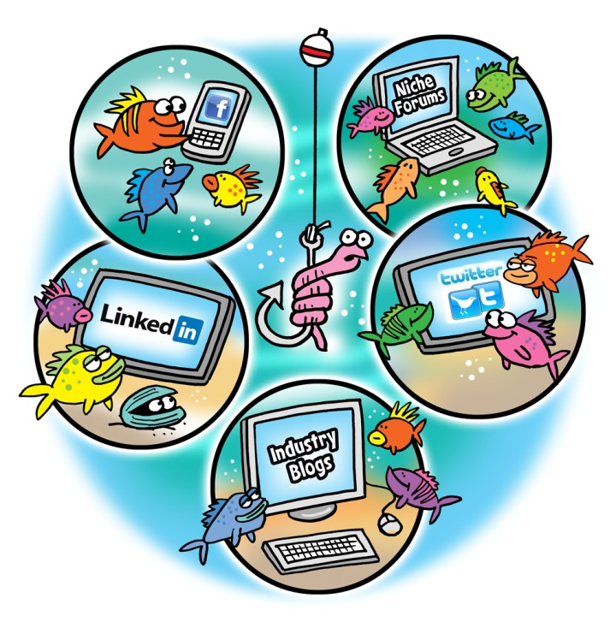
Each respective customer persona has:
- Different ways they get their information
- Different influencers that they respect and follow
- Different people influencing their decisions (peers, friends, bosses, family, etc.)
- Different social networks, forums, blogs or groups they frequent
- Different needs and wants
- Different interests
- Different problems
- Different levels of price sensitivity
- Etc.
Therefore you should rarely develop a marketing strategy trying to target all customer personas. When you do this the message is “watered down” and the message you are looking to convey to everyone doesn’t resonate with any specific customer persona in particular. This will almost always lead to a lower amount of conversions.
By understanding each customer persona intimately you will…
- Know where to find them online or offline
- Know what content or messaging to convey or share on your website, via advertising, email marketing or through your social media initiatives to influence their decision.

Customer Discovery Process
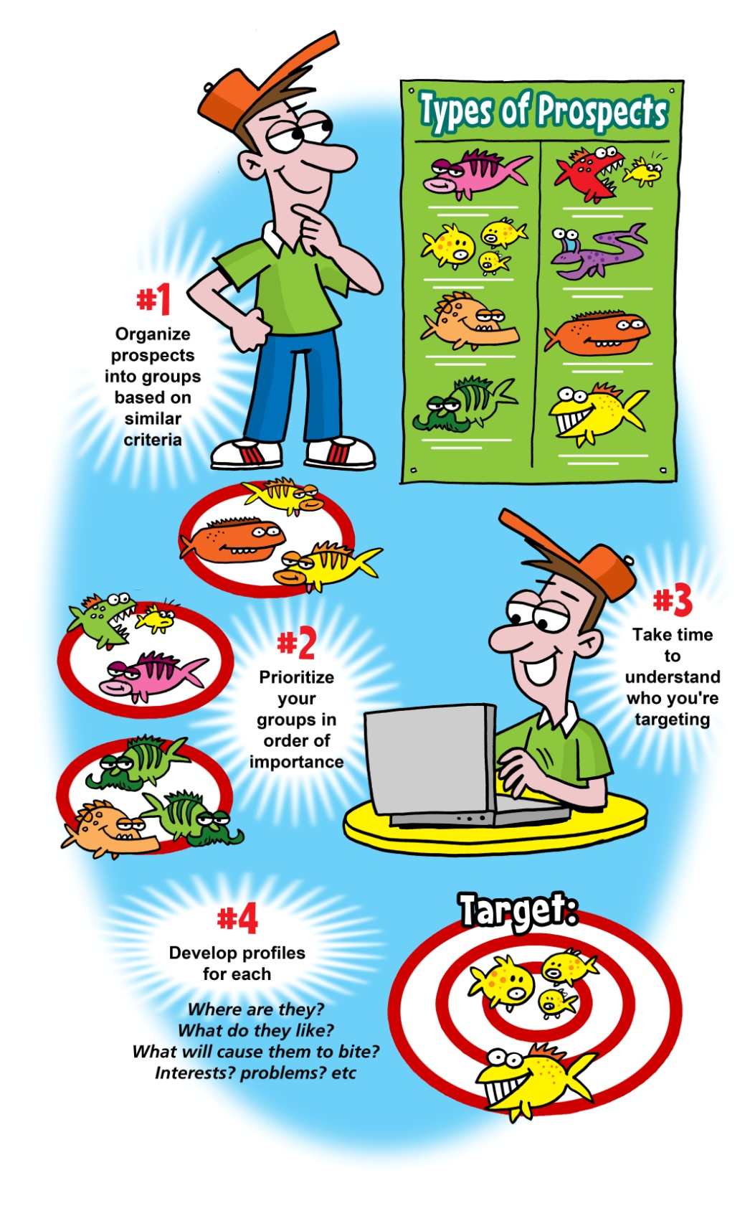

1. Identifying your Customer Personas
List your buyer personas (various customer segments)
The goal of this step is to segment your customers into groups based on similar characteristics, which will enable you the development of specific content, keyword phrases, and messages that will drive the most results. Concentrate on how each customer differs from other, similar customers. Often, the needs of specific customers within a broad industry will be markedly different within their individual markets. Identify those differences as specifically as possible.
These customer groups could be based on any combination of: demographics, psychographics, Specific industries, specific job roles or titles, Job roles within specific industries, economical status/purchasing power, geographical / location, experiences, interests, or past interactions with your company.
*The more specific you are when you create your segments, the easier this segment will typically be to reach and influence from a marketing perspective.

Prospect Focus & Selection

What key prospect(s) do you wish to target? Be specific

1.
2.
3.
4.

Rank your prospects in order of importance

Where are your areas of experience? Who are your most profitable customers? How does each customer segment fit into your overall strategy? These are questions you should ask yourself when determining how customer personas should be prioritized. In addition, consider evaluating each group in terms of highest purchasing power, most influence, easiest to reach, highest frequency/concentration, size of market, strategic advantage gained if customer segment is reached, etc. (Order by priority). Priorities can change over time with further discovery.

1.
2.
3.
4.

Priority Prospect 1

Prospect Name

Quantify the market: (Enter how many of these customers there are)
*How many members of this customer persona exist? This requires research (take your best shot).

Market Size

Prospect Profile: Use the criteria below as needed to help gain clarity of the prospect the business is seeking to reach. Feel free to add your own fields to support your unique situation.

Prospect Criteria | Notes
Demographics (Age, Sex, Ethnicity, Income)
Profession/Job Titles
Working in Industries
Location
Facing Problems
Interested In
Behaviors/Prospect has done this

Is this prospect a decision maker, or influencer?
Decision maker: *If you are targeting a specific industry, or type of company as a buyer persona, you need to understand who the decision maker is within that industry or customer segment. Sometimes the person you could be targeting is not actually the decision maker, but an influencer, or “champion” that could influence the actual decision maker to make a decision.
Influencers / Champions: Champions, or influencers, are those that would potentially be excited about your product and have influence over the decision maker. For instance, an engineer may be a champion, but the VP of Marketing may be the end decision maker. Before the VP signed off on the purchase he would discuss the purchase with the engineer.
Decision maker or Influencer

What message(s) should you communicate?

Key message(s)

Specify below how you plan on reaching this key prospect
How can I reach them?
Consider blogs, forums, groups, strategic partners, search engines / keywords, social media, publications, events, PR, etc.

Priority Prospect 2

Prospect Name

Quantify the market: (Enter how many of these customers there are)
*How many members of this customer persona exist? This requires research (take your best shot).

Market Size

Prospect Profile: Use the criteria below as needed to help gain clarity of the prospect the business is seeking to reach. Feel free to add your own fields to support your unique situation.

Prospect Criteria | Notes
Demographics (Age, Sex, Ethnicity, Income)
Profession/Job Titles
Working in Industries
Location
Facing Problems
Interested In
Behaviors/Prospect has done this

Is this prospect a decision maker, or influencer?
Decision maker: *If you are targeting a specific industry, or type of company as a buyer persona, you need to understand who the decision maker is within that industry or customer segment. Sometimes the person you could be targeting is not actually the decision maker, but an influencer, or “champion” that could influence the actual decision maker to make a decision.
Influencers / Champions: Champions, or influencers, are those that would potentially be excited about your product and have influence over the decision maker. For instance, an engineer may be a champion, but the VP of Marketing may be the end decision maker. Before the VP signed off on the purchase he would discuss the purchase with the engineer.
Decision maker or Influencer

What message(s) should you communicate?

Key message(s)

Specify below how you plan on reaching this key prospect
How can I reach them?
Consider blogs, forums, groups, strategic partners, search engines / keywords, social media, publications, events, PR, etc.

Priority Prospect 3
Copy and paste the template to continue adding your own prospects indefinitely.
This should be a living document that you can edit as you learn more through conversations with each of your key prospects.
You will also likely uncover new prospects, whether decision makers or influencers, throughout your marketing journey.
Feel free to reach out if you have any questions about using this tool to grow your business and improve your marketing.
--
David Brim
Email: david@brandadvance.net
Phone: 412-445-8960
Blog: www.DavidBrim.com

