Customer Discovery Process & Template

You will rarely win in marketing if you don’t know exactly who you are looking to reach with a given marketing initiative. The reason for this is simple…each respective “customer persona” you are looking to reach is unique and unless you understand them intimately your message will not resonate strongly enough to influence them to act. By focusing on specific, differentiated customers, your business can create a bank of knowledge for each of their focus industries and decision makers. This focused approach will allow you to tune your message and marketing approach to each specific customer segment, and avoid taking a "One size-fits-all" marketing approach that targets everyone, but appeals to nobody. By better understanding your customers and segmenting them into very distinct groups, your company will be able to reach each segment with the message that resonates most to them.
I often compare marketing to fishing…you need to “fish where the fish are with an attractive bait that will cause the specific customer you are after to bite”.
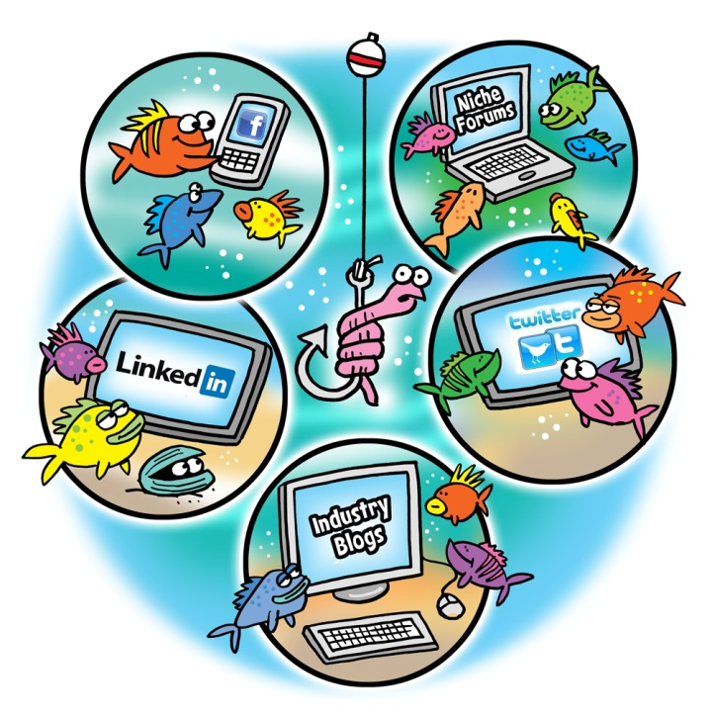
Each respective customer persona has:
- Different ways they get their information
- Different influencers that they respect and follow
- Different people influencing their decisions (peers, friends, bosses, family, etc.)
- Different social networks, forums, blogs or groups they frequent
- Different needs and wants
- Different interests
- Different problems
- Different levels of price sensitivity
- Etc.
Therefore, you should rarely develop a marketing strategy trying to target all customer personas. When you do this the message is “watered down” and the message you are looking to convey to everyone doesn’t resonate with any specific customer persona in particular. This will almost always lead to a lower amount of conversions.
By understanding each customer persona intimately you will…
- Know where to find them online or offline
- Know what content or messaging to convey or share on your website, via advertising, email marketing or through your social media initiatives to influence their decision.

Customer Discovery Process

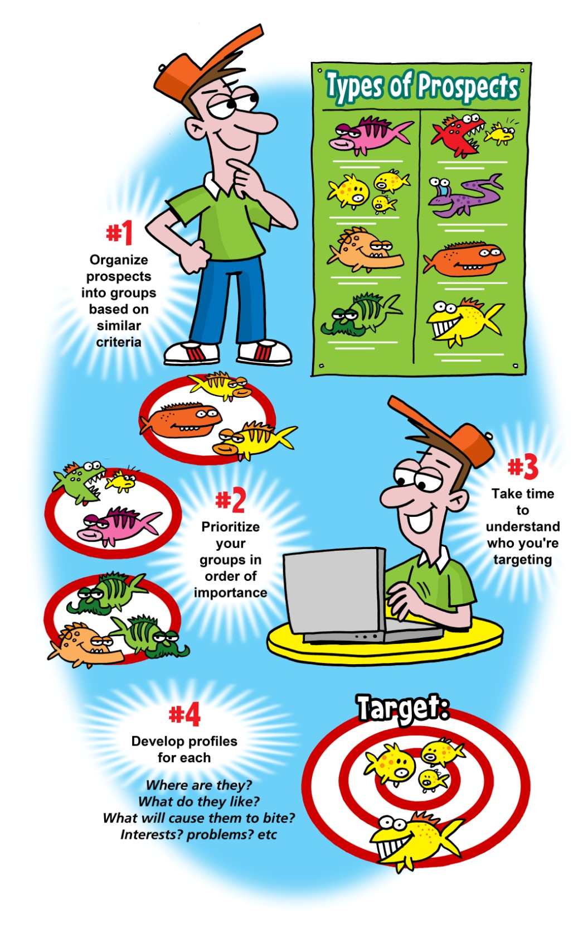

1. Identifying your Customer Personas
List your buyer personas (various customer segments)
The goal of this step is to segment your customers into groups based on similar characteristics, which will enable you the development of specific content, keyword phrases, and messages that will drive the most results. Concentrate on how each customer differs from other, similar customers. Often, the needs of specific customers within a broad industry will be markedly different within their individual markets. Identify those differences as specifically as possible.
These customer groups could be based on any combination of: demographics, psychographics, Specific industries, specific job roles or titles, Job roles within specific industries, economical status/purchasing power, geographical / location, experiences, interests, or past interactions with your company.
*The more specific you are when you create your segments, the easier this segment will typically be to reach and influence from a marketing perspective.
Customer Buyer Personas
Take some time to outline the customer personas that should be considered in your online marketing efforts., I suggest working with your staff or executive team solidify at least three to five customer personas to start:
Specific demographics or job titles within specific industries or locations such as…

*If you need help ironing out B2C (business to consumer) personas, consider reviewing a thorough list from ESRI here.

2. Rank each of your customer personas in order of importance
Where are your areas of experience? Who are your most profitable customers? How does each customer segment fit into your overall strategy? These are questions you should ask yourself when determining how customer personas should be prioritized. In addition consider evaluating each group in terms of highest purchasing power, most influence, easiest to reach, highest frequency/concentration, size of market, strategic advantage gained if customer segment is reached, etc.

3. Understanding Each Customer Buyer Persona
Start creating the buyer persona profiles for your top customer groups
After prioritizing your core customers begin developing buyer personas for each one. Talk or survey your customers or at the most basic level try to think like them. Research associations, advocacy groups, LinkedIn groups, publications, or other areas where these customers communicate to each other and to you. The following “Customer Discovery Check list” may be used as a template, but if you have identified additional areas of concentration, use them as well.
Customer Persona One
Customer Persona One: (Add Name)
Quantify the market: (Enter how many of these customers there are)
*How many members of this customer persona are there? This requires research.
Who are the key decision makers within this market / persona?
*If you are targeting a specific industry, or type of company as a buyer personas you need to understand who the decision maker is within that industry or customer segment. Sometimes the person you could be targeting is not actually the decision maker, but a “champion” that could influence the actual decision maker.
Who are the champions within your highest prioritized segment(s)?
*Champions are those that would potentially be excited about your product and have influence over the decision maker. For instance an engineer may be a champion, but the VP of Marketing may be the end decision maker. Before the VP signed off on the purchase he would discuss the purchase with the engineer.

Demographic description
- Sex:
- Age:
- Income:
- geographic location:
- Family:
- Typical Industries / Job titles:
- Decision Maker Titles:
- Living situation:
- etc:

How do you reach them?
*List each
- Industry blogs
- Associations
- Online groups
- Social networking sites
- Forums
- Referrals
- Industry events
- Webinars
Additional Questions to Answer….
- What are they trying to accomplish?
- What problems are they facing?
- What or who Influences them? (people, trends, media, laws, organizations, etc.)
- What are their job responsibilities?
- What websites do they frequently visit?
- What books, magazines, trade journals or other publications do they read?
- What are their favorite activities?
- What Initial Search terms would they use to find you and your services?
*Think like your customer! They may have specific jargon or phrases that they would use that you would not.
- What is the decision making process of this target customer persona?
- What competitors are succeeding in reaching and selling to this customer segment?
- What are they doing right?
- What can you learn from them?
- What messaging is working?
-What social sites or industry sites are they utilizing to reach and influence the customer?
I hope that you found this to be helpful! If you have any questions please don’t hesitate to reach out to me.
--
David Brim
Brand Advance
www.brandadvance.com
Phone: 407-842-7100 Ext 201
david@brandadvance.net
blog: www.davidbrim.com
twitter: www.twitter.com/davidbrim
LinkedIn: www.linkedin.com/in/davidbrim
My Book: http://amzn.to/17KgN0m

